ADRIAN TURION |  | Avenue de Sainte-Clotilde 9  1205 Geneva, Switzerland | 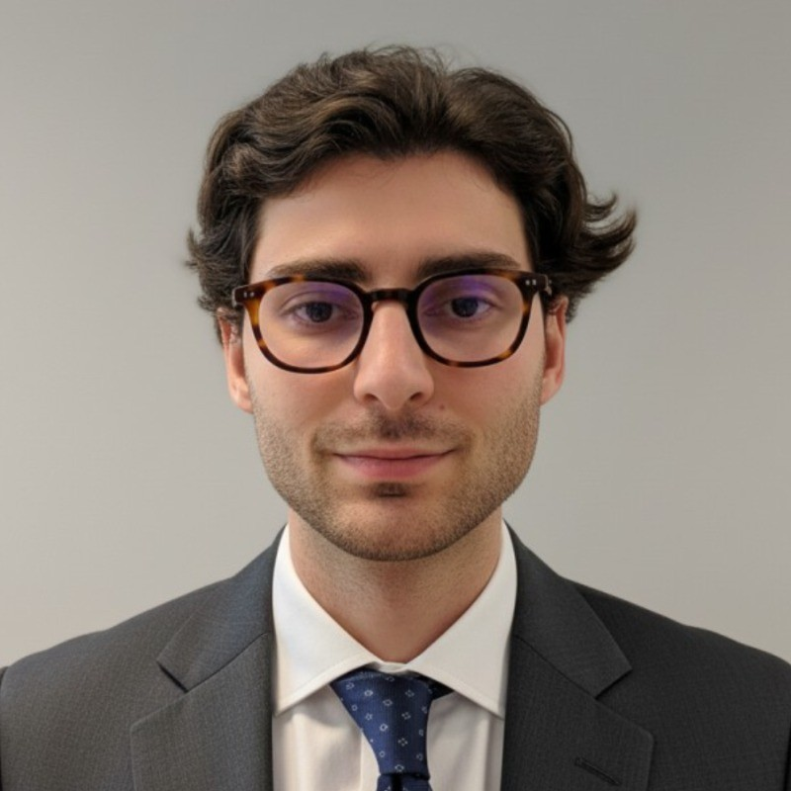
turionadrian@gmail.com | Swiss | 10.11.2000 |  | +41 77 262 37 96
INTRODUCTION
Operations-focused MSc Finance candidate with strong organizational skills and multi-stakeholder coordination experience in fast-paced financial environments. Demonstrated accuracy and timeliness managing 7 concurrent workstreams with client, advisor, and counterparty relationships. Bilingual English/French proficiency and solid foundation in financial markets and compliance.
WORK EXPERIENCE
Auraïa Capital Advisory – Small & Mid Cap Cross-border M&A Boutique  Mergers & Acquisitions Analyst (Converted internship into full-time position) |  | Geneva, Switzerland  Aug 2024 – Current
- Managed relationships with clients, advisors, and counterparties throughout transaction lifecycle, ensuring timely communication and swift resolution of requests across multiple concurrent deals in healthcare, tech, and life sciences sectors
- Coordinated marketing materials production, data room management, and buyer universe maintenance across 7 live mandates simultaneously, demonstrating strong organizational skills and accuracy under significant time pressure
- Collaborated with legal, tax, and accounting advisors to structure transactions and negotiate deal terms, maintaining close cross-team coordination and ensuring full compliance with regulatory requirements

RC Group – Currently under LBO with Crédit Mutuel Equity  Mergers & Acquisitions Intern |  | Paris, France  Feb 2024 – Aug 2024
- Worked directly with the CEO of Healthcare and Retail divisions on evaluating acquisition targets, preparing investment memos with comprehensive market analysis and financial projections while coordinating due diligence across multiple stakeholders in France and Belgium

Europ Assistance – Subsidiary of Generali Insurance  Financial Analyst Intern |  | Geneva, Switzerland  Apr 2023 – Aug 2023
- Built automated financial dashboards in Excel and PowerBI tracking KPIs for the CFO of this CHF 50M+ Generali subsidiary, performed variance analysis on monthly P&L results, and supported annual budget planning and quarterly forecasting for 5 business units

LEADERSHIP
- Led post-COVID financial recovery at AIESEC by sourcing corporate leads, creating tailored pitchbooks, and negotiating 3 key partnerships generating CHF 60K annual revenue
- Manage diversified investment portfolio using Cash Secured Puts and Covered Calls with 45-day expiries, achieving 8% annualized returns through disciplined options strategies
- Presented strategic project to McKinsey consultants and Keyrock management as Top 5 finalist, developing data-driven model with potential CHF 200K annual revenue impact
EDUCATION
HEC Lausanne  Master of Science in Finance |  | Lausanne, Switzerland  2021 – 2024
- Cumulative GPA: 5.2/6.0 (Top 15% of the class cohort)
- Exchange programs at Waseda University (Tokyo, Japan) and Maastricht University (Maastricht, Netherlands)
- Relevant Coursework: Investment and Portfolio Management, Risk Management, International Finance
- Thesis Topic: Synergies Analysis of the Merger between American Airlines & US Airways

Bachelor of Science in Management |  | 2018 – 2021
- Cumulative GPA: 4.7/6.0

Scientific Baccalaureate with Highest Honors (16.6/20) |  | Aix-en-Provence, France
ADDITIONAL INFORMATION
Languages:  Computer:  Interests:  References: | French (Native, C2), Spanish (Native, C2), English (Fluent, C1), German (Business proficient, B2-C1)  Financial Markets | Client Relations | MS Office | Risk Management | French (Native)  Geopolitics, Badminton (Provence regional finalist), Gym, Real use cases of Artificial Intelligence  Guillaume Arnaldez – Ex-Director at Auraïa Capital Advisory, guillaume.arnaldez@auraia.ch  Sacha Caravatti – CFO at Europ Assistance Switzerland, scaravatti@europ-assistance.ch

